Student Group By-Elections

Handbook 2024/2025

Contents
Introduction and Timeline 3
Election Timeline 3
Committee Roles 4
Which committee roles are compulsory? 4
How should I structure the rest of my committee? 4
Who can be on a Student Group Committee? 5
Do New Student Groups have to take part? 5
What additional requirements are there for Team Leicester? 5
Can an Interviewed Role be a Committee Member? 6
Can I run for multiple committee positions in the same Student Group? 6
Can I run for multiple committee positions in different Student Groups? 6
Running an Election 7
Before the Election 7
Nomination Period 8
How do I nominate myself for a role? 8
Submitting a Manifesto 9
Voting Period 11
How to Vote 11
Single Transferable Voting (STV) 13
Re-Open Nominations (RON) 13
Tied Elections 13
Election Complaints and Concerns 13
Results Week 14
How will we receive the results? 14
Finding and Supporting Prospective Committee Members 15
Recruitment 15
Writing a Manifesto 15
Committee Member Job Descriptions 17
Additional Committee Member Job Descriptions 18
Changelog 20

Introduction and Timeline
Student Group Elections are just around the corner! As part of the Students’ Union’s Constitution, all committee positions must be put up for election every year to ensure that your Student Group’s membership has an opportunity to choose who will lead them next year.
To ensure that your election is recognised by the Students’ Union, all Student Group elections are created by the Activities & Volunteering department and will be listed on our website under ‘Student Group Elections 24.25’
– your Student Group will receive weekly updates regarding your nomination and voting statistics.
Remember: If any roles are left unfilled, we will follow this election with a by-election in May. We expect all Student Groups to take part in both the main election and by-election to give the best chance of having a full committee.
  - Need Support?
We know that getting your Student Group ‘election-ready’ can be a daunting experience and want to assure you that the Activities & Volunteering Team is on hand to answer any questions. Our working hours are 10am-4pm Monday to Friday and you can get in touch at unionactivities@le.ac.uk

Election Timeline
This year, all Student Group Committee elections will run across the following dates:
- Monday 19/02/2024 (9am) – Deadline to submit Committee Position Changes and Election Coordinator
- Friday 19/04/2024 (Midday) – Nominations Open
- Monday 29/04/2024 (Midday) – Nominations Close
- Wednesday 1/05/2024 (Midday) – Voting Opens
- Friday 10/05/2024 (Midday) – Voting Closes
- Week Commencing 13/05/2024 - Results counted and sent to Election Coordinators

Committee Roles

Which committee roles are compulsory?
To remain affiliated with the Students’ Union, all Student Groups must have the following ‘core’ positions filled by the end of the by-election period in May 2024:
- President/Club Captain
- Treasurer
- Wellbeing and Inclusion Ambassador
When advertising your elections, the Activities & Volunteering department would strongly recommend prioritising these, as they are necessary for your Student Group’s affiliation.
Please note: The roles of President, Treasurer and Wellbeing and Inclusion Ambassador cannot be held alongside any other position on committee.

Changes to the ‘Secretary’ role
Your Student Group is more than welcome to still have ‘Secretary’ as a core role within your Student Group Committee, however it will no longer be required for your Student Group’s affiliation with the Students’ Union.

How should I structure the rest of my committee?
Any additional positions in your Student Group’s committee structure are completely customisable to your Student Group. For example, you may want to add a Publicity Secretary, Social Secretary or Coach to your committee structure. If you decide to make any changes, remember to tell the Activities & Volunteering Department by submitting your Committee Position Changes form before 9am on Monday 19th February 2024.
When deciding how to structure next year’s committee, we recommend meeting as a current committee to reflect on your time in post with the following areas of discussion:
- Did the current structure work effectively?
- Were responsibilities equally divided, did some committee roles have too much and others have too little?
- Which roles are crucial to the effective functioning of your Student Group and should be prioritised?
- Could the responsibilities of each role be redistributed to ensure your committee could function if reduced?
We would also recommend you meet with your Student Group’s Development contact in either Activities & Volunteering or Sport and Active Life to discuss your committee structure.

Who can be on a Student Group Committee?
To run for a committee position, nominees must be:
- A registered student with the University of Leicester for the 2024/2025 academic year or a student on a year of suspended study/year without residence.
And
- A current standard member of the Student Group who plans to remain a member in the 2024/2025 academic year.
A person cannot run in the Student Group Elections if:
- They are an associate member, alumni member, or a full-time staff member of the University of Leicester or Students’ Union.
- They will be studying abroad or on a year in industry in the 2024/2025 academic year.
- They are under the age of 18.

Do New Student Groups have to take part?
If you are part of a New Student Group that was first affiliated to the Students’ Union between September 2023 and June 2024, you do not need to run an election unless you have a committee member leaving (for example, they are graduating or do not want to retain their position) or you would like to add more roles. We will send out a specific ‘New Group Election Guide’ to help you with this process.

What additional requirements are there for Team Leicester?
Team Leicester Committees are also supported by the University of Leicester’s Sport and Active Life Departments and must adhere to the following guidance:
  - Team Captains
The Students’ Union and Sport and Active Life Department are currently in discussions regarding the timeline for the election/choosing of Team Captains. Team Leicester will be in touch with Club Captains with more information in the very near future in regard to a consultation process. At this point please do not nominate any team captains’ positions as part of the election nomination process.
  - Additional Responsibilities
Prospective Team Leicester committee members should be aware that they will be asked to attend additional Team Leicester training days in Term 3 and in Term 1.

Can an Interviewed Role be a Committee Member?
Due to the Students’ Union’s democratic guidelines and policies, any role that would require an interview, such as a project lead, cannot be a committee member role. If you require any additional information about how to host an interview for a role, including best practice, please contact the Activities & Volunteering Team.

Can I run for multiple committee positions in the same Student Group?
Students can run for multiple committee positions within the same Student Group under certain circumstances. For example, if a prospective Presidential candidate also wants to run in a non-core position (for example, Social Secretary), they should understand that if they win both positions, they can only take the Core committee position (in this case the President).

Can I run for multiple committee positions in different Student Groups?
Students are welcome to run for as many positions as they feel they are able to undertake across multiple Student Groups. Additionally, you may hold core committee roles in different groups (for example, being a President in Group A but also in Group B).
In the situation a candidate wins multiple elections but wishes to step down from a role, we will award the role to the second placed candidate.

Running an Election

Before the Election
  - Submitting Committee Position Changes
Fill in this form if your Student Group wants any changes made to your committee positions for the 2024/2025 academic year. If you do not fill this in, we will assume that you are looking to elect the same committee positions your Student Group has this year. The deadline for submitting this is Monday 19th February 2024 (9am).
  - Choosing an Election Coordinator
To ensure that the election can run smoothly, it is important that the Activities & Volunteering Team has a main point of contact for your Student Group (known as the Election Coordinator). This person’s role is as follows:
- To act as the elections, point of contact for the Activities & Volunteering Department
- To contact the Activities & Volunteering Department with any problems or concerns regarding the election
- To promoting the election to the membership by sending around any voting links etc.
The Election Coordinator must be a member of your Student Group who is not running for a committee position next year nor supporting any other candidates.
Please Note: This person does not have to be a committee member and does not have to be elected into the role. We recommend someone who is graduating.
You can submit your Election Coordinator here. The deadline for submitting this is Monday 19th February (9am).
  - Are membership sales staying live?
To ensure no election is impacted by late memberships being purchased, all Student Group membership sales will go offline between nominations opening (Friday 23/02/2024 (Midday)) and voting closing (Sunday 24/03/24 (Midday)).
If your membership is displaying on the website, please contact unionactivities@le.ac.uk. Additionally, if your Student Group would like membership sales to remain online during the elections, let us know!
  - Promoting your election
Promoting your upcoming election to members is crucial to getting the best engagement and securing nominees for all of your committee positions. It is important to gauge interest in the roles, and to see any areas that you have no possible candidates.
When advertising your elections, we would strongly recommend prioritising the core committee roles of President, Secretary, Treasurer and Wellbeing & Inclusion Ambassador, as these are crucial to the affiliation and continuation of your Student Group.
Please Note: The Students’ Union will be requiring Student Groups to promote all roles on social media to ensure that all students have a chance to run.

Nomination Period
Friday 23 February 2024 (Midday) – Sunday 10 March 2024 (Midday)
Throughout the nomination period, your Student Group’s election coordinator will receive updates from the Activities & Volunteering Department. These updates will include information on how many candidates are currently standing for each committee position.

How do I nominate myself for a role?
To nominate themselves, students should the ‘Student Group Elections’ webpage and scroll down to ‘Student Group Election 23.24’ which will display the posts that they are eligible to stand for. They will then need to follow the following steps:
- Click ‘Stand In Election’ (Picture 1A: ‘Stand in Election’)
- Enter information into ‘Your Details’ including Display Name, Email and Phone Number
- Scroll down to ‘Review Nominations’ and click ‘Stand’ for the position you wish to stand in (Picture 2A: ‘Review Nominations’)
Please Note: If someone cannot view the election they would like to stand in, they must ensure that they are a current member of that Student Group. (See page 3, ‘Who can be on committee?’) If the issue persists, a Student Group’s election coordinator should contact unionactivities@le.ac.uk as soon as possible before nominations close on Sunday 10th March at 12:00pm (Midday).

  - Picture 1A: ‘Stand in Election’
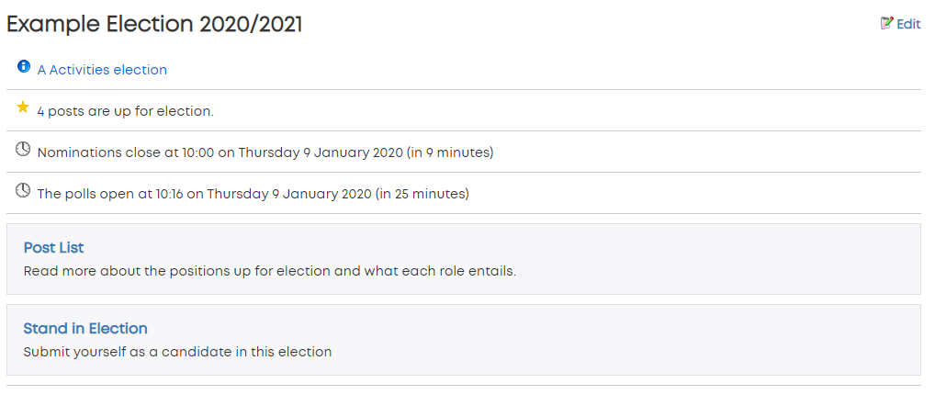

  - Picture 2A: ‘Review Nominations’
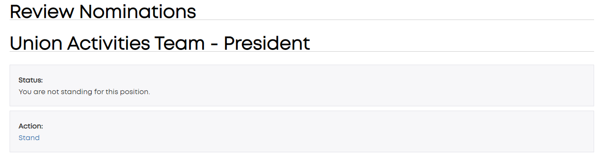

Submitting a Manifesto
A manifesto does not have to be submitted at the time of nomination, but it must be submitted before nominations close on Sunday 10 March 2024 at 12:00pm (Midday). To submit a manifesto, nominees should visit www.leicesterunion.com/studentgroupelections.
They will then need to follow the following steps:
- Scroll down to ‘Student Group Election 21.22’ and click ‘Review Nominations’ (as seen in Picture 1B: ‘Review Nominations’)
- Scroll down to the Committee position they are running for and click ‘Upload’ (Picture 2B).
- Nominees will then be presented with an option to upload a picture along with writing their manifesto. (Picture 3B: ‘Uploading a Manifesto’)
For more information on how to write a manifesto, head to the ‘Finding and Recruiting Prospective Committee Members’ section.
Please Note: Your nomination will have the ‘Pending Approval’ status until the Activities & Volunteering Team has reviewed all nominations following the close of nominations. A nomination will not be approved if the manifesto content breaks the Students’ Union or University of Leicester’s Code of Conduct. Further action may be taken by the Union in line with disciplinary processes.

  - Picture 1B: ‘Review Nominations’
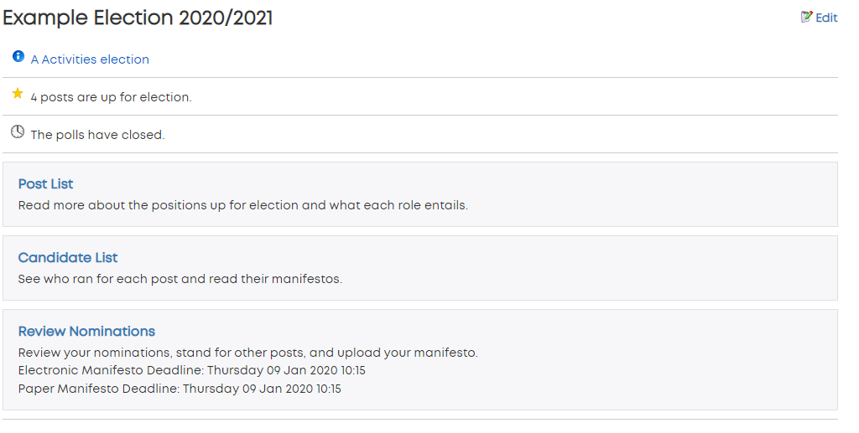
  - Picture 2B: ‘Pre-Manifesto Upload’
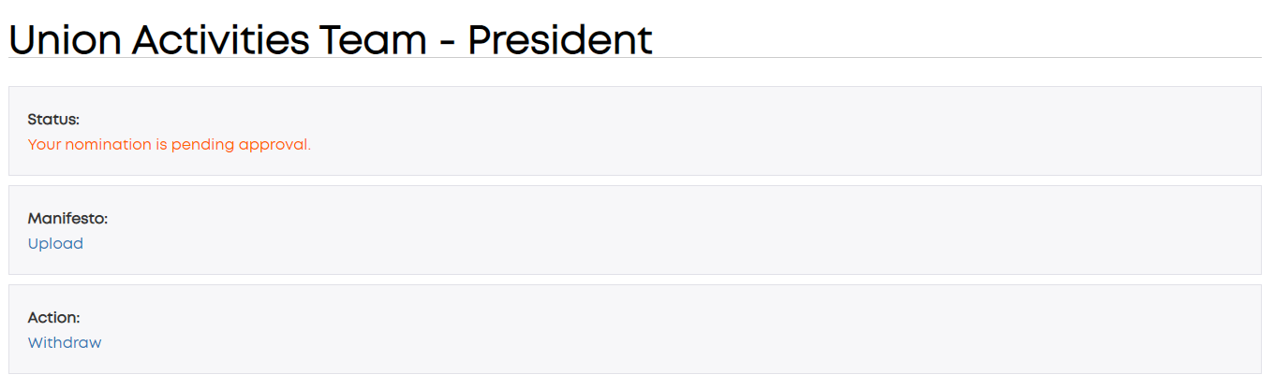
  - Picture 3B: ‘Uploading a Manifesto’

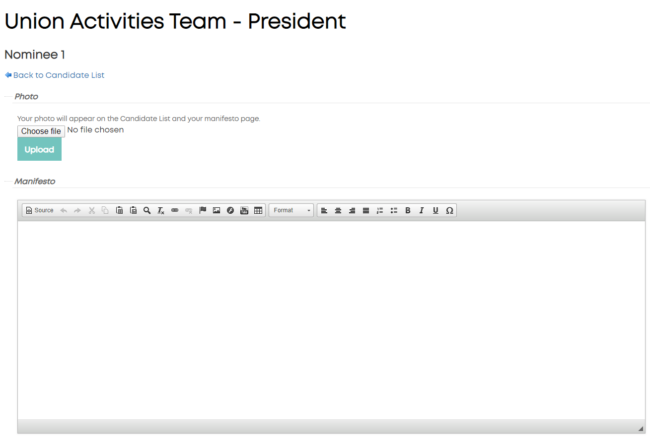

Voting Period
  - Friday 15 March 2024 (Midday) – Sunday 24 March 2024 (Midday)
  - The voting period allows your membership to exercise their right to vote and choose who will lead the Student Group in the next academic year.
  - Please Note: If there are no votes, no one will be elected and the election will have to be re-run in the by-election period in May 2024.

How to Vote
To vote, members should visit www.leicesterunion.com/studentgroupelections.
They will then need to follow the following steps:
- Scroll down to ‘Student Group Election 23.24’ and click ‘Vote Now’ (Picture 1C: ‘Vote Now’)
- Voters will then be presented with a list of positions they are eligible to vote for along with an option for ‘Start voting’. Nominees can vote for themselves. (Picture 2C: ‘Start Voting’)
- Voters will then be asked to rank their candidate preference along with being given the option to read their manifesto (Picture 3C: ‘Choosing Candidates’) before choosing ‘No further preferences’.
- Voters will then be asked to review their options before choosing ‘Cast Vote’ if they are happy and ‘Back to Ballot’ if they want to change their vote. (Picture 4C: Reviewing Preferences’).
Please Note: Only current members of your Student Group can vote in the election. If someone cannot view the election they would like to vote in, they must ensure that they are a current member of that Student Group. Associate and alumni members are not able to vote. If the issue persists, a Student Group’s election coordinator should contact unionactivities@le.ac.uk as soon as possible before voting closes on Sunday 24 March 2024 at 12:00pm (Midday).
  - Picture 1C: ‘Vote Now’
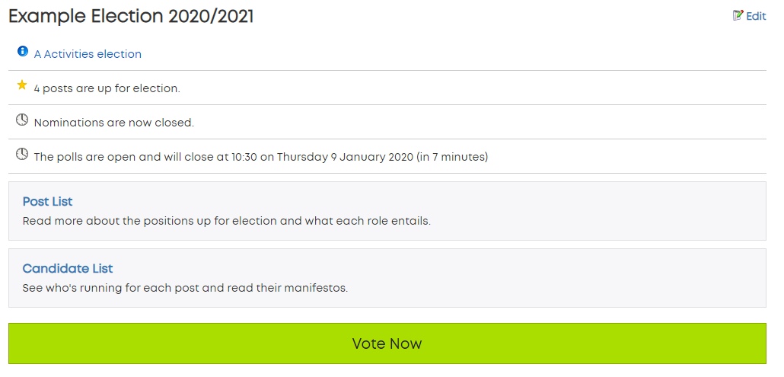

  - Picture 2C: ‘Start Voting’
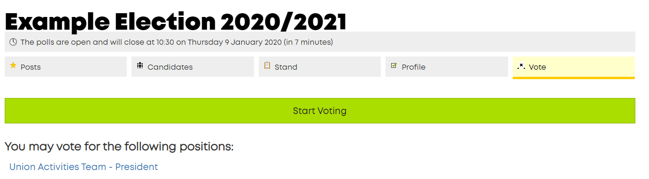
  - Picture 3C: ‘Choosing Candidates’
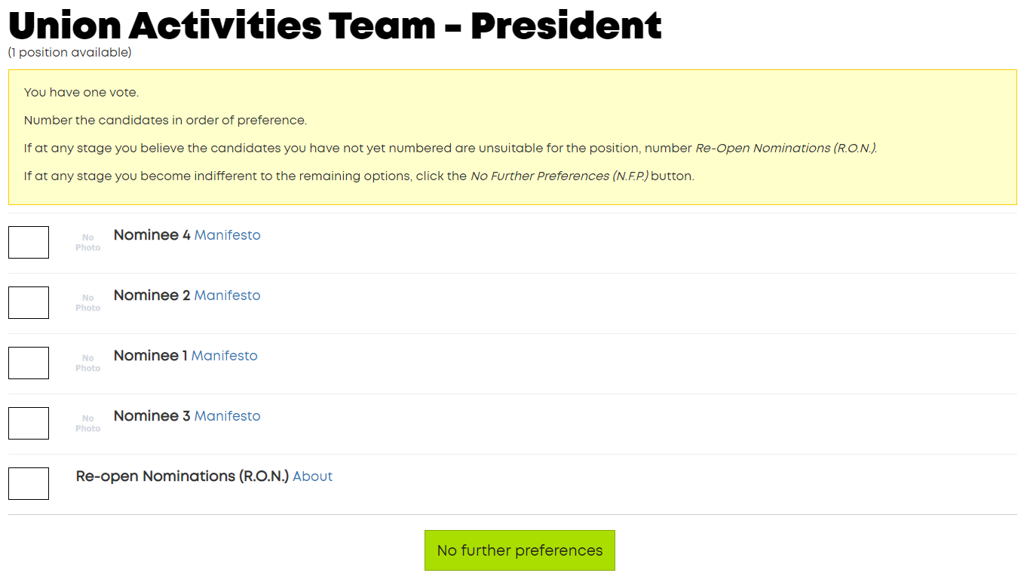
  - Picture 4C: ‘Reviewing Preferences’
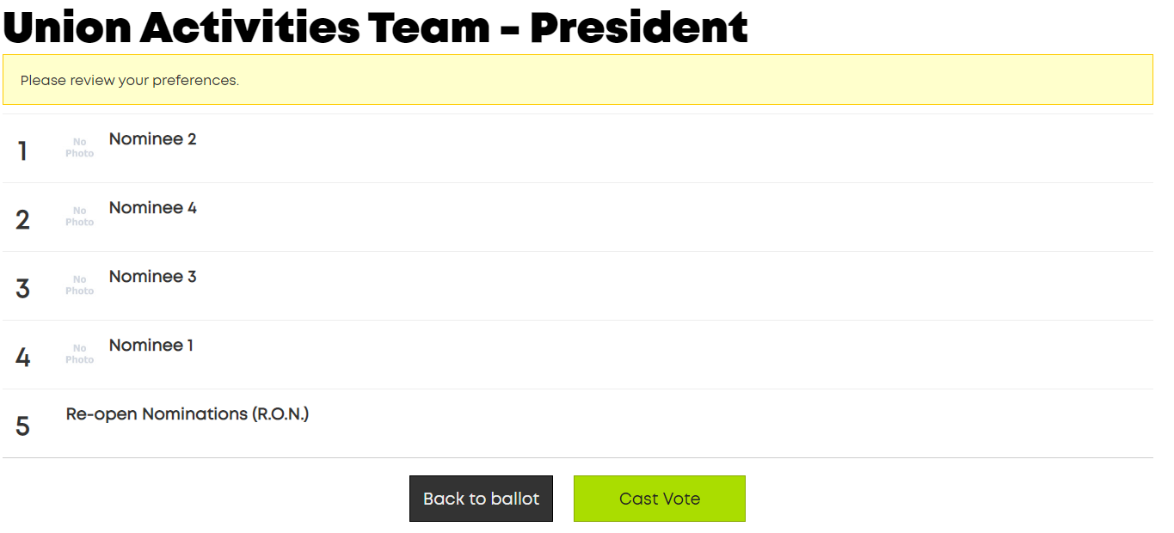

Single Transferable Voting (STV)
All Student Group Elections run on a Single Transferable Voting (STV) system on www.leicesterunion.com. Voters are asked to rank candidates in order of preference i.e. 1st Choice, 2nd Choice, 3rd Choice. In the count-up, the lowest ranking candidate is eliminated at the end of each round and the votes are redistributed.
For more information on Single Transferable Voting, head to the NUS’ video guide here.

Re-Open Nominations (RON)
For every role in the election, Re-Open Nominations is an option. This allows voters to express the opinion that they feel the candidates running aren’t suitable. If RON wins then nominations are re-opened and the election runs again.

Tied Elections
Should an election be tied, an independent member of staff will flip a coin to decide the result or a job share can be decided.

Election Complaints and Concerns
For queries or concerns regarding any Student Group Election, please contact unionactivities@le.ac.uk FAO Aaron Valand.
If you wish to submit a formal complaint, please visit www.leicesterunion.com/surveys/SGElectionComplaint/. This will be dealt with by the Activities & Volunteering Department in the first instance, and escalated to the Students’ Union Scrutiny committee if necessary.

Results Week
Week Commencing 25th March 2024

How will we receive the results?
During the Results Week, your Student Group’s elections coordinator will receive an email from the Activities & Volunteering Team notifying them of the full outcome of the Committee Election.
  - Handover
Following election results week, it is the beginning of committee handover! Please remember that all 2023.24 committee members are still in place until Monday 1 July 2024. More information on handing over a committee will be released in due course.

Finding and Supporting Prospective Committee Members

Recruitment
There are many ways to promote your committee roles to prospective nominees. Think about using social media (such as Facebook, Twitter or Instagram) or start to talk about it at your events to make sure that your members are encouraged to utilise their right to vote! You could also make a promotional video or, for academic groups, promote the election to your course mates.
Some other ideas to encourage people to run can include:
- Transferable Skills: Being on committee means that you gain loads of transferable skills, from teamwork and communication to building public speaking skills and problem solving.
- Promoting achievements: Show off what your group has achieved in the last academic year and encourage people to build on this success. Make them feel part of the community!
- Reassurance: Sometimes, people are a little nervous about running for committee due to the time commitment. Let them know about the resources available to help them succeed on committee!

Writing a Manifesto
A manifesto is a public declaration of aims and policies that the nominee wishes to complete should they be elected. It is encouraged that prospective committee members write one to show their suitability for the role.
  - What should a manifesto include?
- Experience: Talking about your experience is crucial for demonstrating skills suitable for the role that you are nominating yourself for. For example, if you were running for president, you could mention sometimes you have been a team leader on a project. If you were running for publicity officer, you could write some information about your design experience.
- Passion: There is nothing better than showing how excited you are to run for this position, maybe talk about what interested you in the Student Group in the first place, and your enthusiasm for learning new things!
- Aims and Objectives: These are crucial to the success of your manifesto, check out the information below for more information.
- Concise and clear language: Make sure that you get your points across clearly and concisely so that you don’t lose interest from voters!
- Be informed and representative: You are more likely to appeal to the electorate if you bring up points that are relevant for them – for example, if you know that people want more socials, you could bring that into your manifesto points.

  - Creating aims to achieve
When writing a manifesto, we recommend all aims and objectives are SMART:
- Specific: What exactly do you want to achieve
- Measurable: What will success look like?
- Achievable: Can this be achieved in your role?
- Relevant: Is it relevant to your group’s aims and objectives?
- Timely: Can you achieve it in the next academic year?

  - Structuring a Manifesto
- Introduction – Hello, my name is [Name] and I am running for the position of [Position]
- Experience and Skills – I believe that I am suitable for this role because…
  - Talk about your past roles and experiences that you feel are relevant to the role that you are running for. This could be anything from your interests to your part-time roles
- Aims and Objectives – If I am elected into this role, I would like to achieve these [number] points
  - We recommend highlighting at least 3 plans for if you are successful in the election
  - Think about why each of the aims are important to you and the electorate and how you will achieve your goal for each one
- Closing Statement – To summarise, I would hope to do [Goal] because of [Experience and Skills]. Make sure to vote by visiting www.leicesterunion.com and clicking the link!

Committee Member Job Descriptions
Some prospective committee members may find it helpful to have a role description. To help, see below for the template given in the Student Group Constitution and add to these as you see fit. The responsibilities below are from the Student Group Constitution and are not exhaustive. The main thing is that you are transparent about these tasks early on.
You may also notice that paperwork is not the responsibility of just one committee member – your group should work collaboratively to ensure everything is submitted on time.
  - President
- Oversees the overall running of the Student Group.
- Ensures that the Student Group adheres to the constitution, Policies and Guidelines set out by the University of Leicester Students’ Union and Activities & Volunteering.
- Represents the Student Group to the Students’ Union, University and any external stakeholders.
- Ensures that all Student Group activities are appropriately coordinated and executed with all relevant paperwork submitted to Activities & Volunteering.
- Ensures that all Student Group committee members are fulfilling their constitutional duties.
- Cascades all information from Activities & Volunteering, Students’ Union, University and any external stakeholder down to relevant committee members and Student Group members.
- Cannot hold another core position within the Student Group.
  - Treasurer
- Keeps an accurate record of all expenditure and income of the Student Group.
- Acts as the primary signatory of the Student Group funding account.
- Is responsible for all grant funding applications and other financial dealings (including but not limited to sponsorship) and other financial dealings with the Union and other external bodies.
- Processes deposits and withdrawals from the funding account.
- Ensures prompt reimbursement of all approved expenditure.
- Ensures all funds are held and processed through the Student Group's funding account with the Students’ Union in line with Student Group financial policies.
- Ensures that all incoming money is deposited as soon as possible with the Students’ Union.
- Produces a termly report, year budget and statement submitted to retain transparency with the Student Group membership.
- Cannot hold another core position within the Student Group.
  - Wellbeing and Inclusion Ambassador
- Responsible for supporting the welfare of the membership with the aim of resolving issues of concern, reporting all violations of the Code of Conduct to the Student Group President (if appropriate) and Activities & Volunteering.
- Acts as the point of contact for any issues or general concerns that a member may have regarding the Student Group’s inclusivity.
- Can confidently sign post members to relevant services with the assistance of Leicester Talks with the aim of highlighting support services offered by the University of Leicester, Students’ Union, other Student Group and the community.
- Upholds confidentiality at all times both during and post time in office unless reporting to Activities & Volunteering or the University’s Welfare Services.
- Acts only as a sign poster and not a counsellor.
- Cannot hold another core position within the Student Group.

Additional Committee Member Job Descriptions
The list for possibilities for additional committee members are endless, however it is important to consider which members of committee are necessary to your group to achieve your aims and objectives. Positions can include but are not limited to:
- Social Secretary
- Secretary
- Equipment Secretary
- Vice President
- Publicity Secretary

To help you out with promoting your committee positions, we have put together a few example role descriptions.
  - Secretary
- Maintains the membership records of the Student Group in line with GDPR and Activities & Volunteering membership policy.
- Takes responsibility for recording accurate minutes of all Committee and General meetings of the Student Group, and for the distribution of minutes and agendas for meetings through the mailing list.
- Ensures Student Group adheres to the Constitution, Policies and Guidelines of the Student Group.
- Maintains an up-to-date copy of the Student Group Constitution with any amendments being submitted to the Activities & Volunteering team to be ratified by the Activities Officer.

  - Social Secretary
- Organises socials and events for the Student Group
- Responsible for the safety of all members on socials
- Organises tour in collaboration with other committee members
- Liaises with the Students’ Union for all ticket sales for events
- Work with the Publicity secretary to ensure the adequate publicity of all Student Group events to members

  - Equipment Secretary
- Ensures the Student Group inventory is up to date throughout the year.
- Takes care of Student Group equipment and collaborating with the Treasurer to replace equipment when necessary.
- Ensures that all Student Group equipment is safe for player usage
- Liaises with the Club Captain and Treasurer to expand clothing and equipment range
- The contact for people borrowing, returning and lending equipment
  - Vice President
- Assists the president in the running of the Student Group
- Steps up and fills the position of president should they be unavailable
- Supports other committee members in their projects alongside the president
  - Publicity Secretary
- Looks after the Student Group’s presence online across all social media platforms in line with the social media policy.
- Responsible for promoting campaigns and events run by the Student Group.
- Maintains the Student Group’s Students’ Union webpages.
- Responsible for the advertising the image of the Student Group brand.
- Creates publicity materials for all Student Group events.

Changelog

15/01/2020 – Launched Online
20/01/2020 – Minor grammatical updates, committee position change survey updated
24/01/2020 – Adding ‘Running for Multiple Committee Positions’
30/01/2020 – Added ‘Removing Membership Sales at Nominations’
19/01/2021 – Updated for the 2021/2022 Elections
19/01/2022 – Updated for the 2022/2023 Elections
01/01/2024 – Updated for the 2024/2025 Elections

