Development Goals Coordinator Handbook 24/25

Content:

- Introduction
- Picking a Goal/s
- Planning Guide
- Tracker
- Checkpoints and SDG Workshop
- End of Year Recognition
- Useful Resources

Introduction:
The United Nations has developed 17 sustainability goals to work towards a more prosperous, equal and inclusive world. In line with our growing development of sustainability within the Students’ Union, we are introducing coordinators to all student group committees to take responsibility for the impact their group makes and to work on 1-3 of the goals throughout the year. It is also a great way of tracking any fundraising accomplishments.
As part of the affiliation process, each student group should discuss between them who in their committee is interested in taking on being the development goal coordinator (in a similar process to the election coordinators). It can be anybody who is simply passionate about the subject, but will automatically be assigned to the wellbeing and inclusion ambassador should your group not decide otherwise. If you feel there is a need to over time, you could add it as an official committee position but it is totally up to your groups aims and needs!
It is compulsory for a student group to have a coordinator, however it requires no specific level of commitment or number of hours and is completely up to the coordinator as to what they do with the role.

Picking a goal/s:
There are a wide variety of topics covered within the goals. It isn’t just about climate action and being sustainable, but also human rights, justice, economical and political change as well as so much more. The first job of a coordinator should be to look into each of the gaols and work out which ones are relevant to your student group.

The goals are (click on the icon for more info or check the goals breakdown guide):
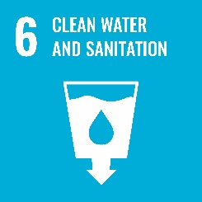

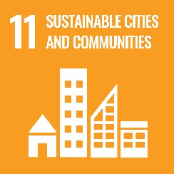

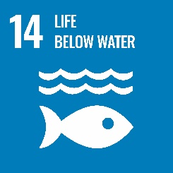

In picking a goal you could consider….
- What awareness or advocacy topics your group are particularly passionate about?
- If you already are working on any of the topics or if you want to work on an additional/new one.
- Any partnerships or connections you have with external organisations or sponsorships.
- What goals are relevant to your student group activities, aims, objectives or regular topics of discussions?
- If you are a national/cultural group, what themes or issues are prominent within your community right now?
- But also, what are you as the coordinator most interested in?
- Medical groups – try to think outside of goal 3, what other goals could you work on top of that?
You can also check out this video that helps break things down a bit more.
It is compulsory to pick 1 goal, but you can decide to pick up to 3 depending on how much commitment you want to put in or if you feel you can work on/or already working on more then that.
Once you have decided and confirmed it with the rest of your committee, please fill in your development goal confirmation form.

Planning Guide:
You can use the following guide to plan out how you can achieve your goals and to help spark up ideas.
Prompt
What ways are your student group already working on your goal/s?

Are there any world events, awareness days or issues particularly prominent within your topics that you could raise awareness of?

Do you know of any organisations, charities or campaigns working within your goal/s that you can reach out to/fundraise for?

What sort of events could you hold both within your society and out in the wider student body/community?

In what way could your student group campaign to improve the situations within your goal/s, or use their platform?

Who within the university or Students’ Union could you reach out to for additional support specifically within your goal?

How could your other members of committee help to support or get involved in achieving your goals?

Additional Ideas/Notes:

Tracker:
The tracker is to be used throughout the year for keeping up with what you have done to work on your goal/s as well as any information you will need to share at the end of the year.
You will also need your tracker for catch up meetings with the SU and for consideration in end of year award.
Aim/objective is where you can link back to your confirmation form as to which aim/objective it meets.
Please ensure it is dated and that evidence is provided/attached.

Date | Aim/Objective | How | Evidence

Checkpoints and SDG Workshop:
Following committee training, you should expect to receive an email invite to an SDG workshop where we can help you kickstart your role. It isn’t compulsory but may be helpful to understanding your goal/s, the handbook, what to expect as well as to support you in setting up a plan or deciding on a goal/s, should you feel you need the additional support.
There will also be checkpoints at 2 separate times within the year where you will be expected to submit an updated tracker and can request for a check in chat with the SU.
This way we can ensure that you’re on track to achieving your aims and objectives, plus it may be helpful to staying updated; receiving support with running events or getting general advice. Checkpoint meetings aren’t compulsory but are recommended.

End of Year Recognition:
To celebrate every student group’s hard work and your development goal coordinators achievements, there will be an awards ceremony at the end of the year as well as prizes for the groups who create the most impact within their goal/s.
To ensure you are recognised please complete your checkpoints and keep the SU in the loop with any and all advancements throughout the year.
Again, this isn’t a race and any commitment level is accepted. We want you to work on your goal/s in a way that is right for you as well as your society, and uphold that any number of achievements are impactful.
We also want to ensure that those that do go above and beyond are recognised for their contributions and that prizes will be awarded to help those groups develop on any projects in the following year.

Useful Resources and Contact:
Resources
- UN 17 Sustainable Development Goals Main Page Website Link
- Icons, Downloads and Guidelines
- Students’ Union Committee Hub
- Goals Breakdown
Contact
- unionactivities@leicester.ac.uk

