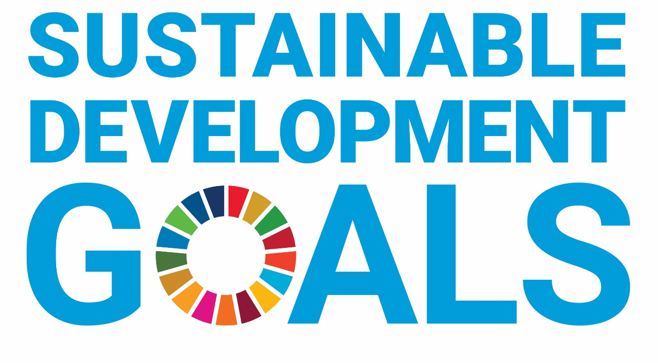

Introduction Guide

This year we are introducing development goal coordinator roles as part of your affiliation process and society activities.
What does this mean?
As part of the affiliation process, each student group should discuss between them who in their committee/wider membership is interested in taking on being the development goal coordinator (in a similar process to the election coordinators). It can be anybody who is simply passionate about the subject, but will automatically be assigned to the wellbeing and inclusion ambassador should your group not decide otherwise. If you feel there is a need to over time, you could add it as an official committee position but it is totally up to your groups aims and needs!
It is compulsory for a student group to have a coordinator, however it requires no specific level of commitment or number of hours and is completely up to the coordinator as to what they do with the role.
Once you have decided on a coordinator, the coordinator should read through this handbook and complete the confirmation form to be submitted alongside your constitution.

What are the sustainable development goals?
The United Nations has developed 17 sustainability goals to work towards a more prosperous, equal and inclusive world. The cover a range of topics from poverty, gender equality, global conflicts, carbon emissions to community impact.
In line with our growing development of sustainability within the Students’ Union, we are introducing coordinators to all student group committees to take responsibility for the impact their group makes and to work on 1-3 of the goals throughout the year. It is also a great way of tracking any fundraising accomplishments.

Here’s other ways you can learn more about the SDG’s:
- UN Website - https://sdgs.un.org/goals#implementation
https://sdgs.un.org/topics
- Good Life Goals Video - https://www.oneplanetnetwork.org/programmes/sustainable-lifestyles-education/good-life-goals
- Development Goals Breakdown Presentation

